**Title: Road Safety and Accident Patterns in India**

**1. Introduction:**

Road safety is a critical issue in India, a country with one of the largest and most diverse road networks in the world. The rapid growth of the economy, urbanization, and motorization has led to a significant increase in the number of vehicles on the roads. However, this growth has not been accompanied by corresponding improvements in road safety infrastructure, regulations, and awareness, leading to a high incidence of road accidents.

The patterns of road accidents in India are influenced by various factors, including the type of road, time of day, weather conditions, and the behavior of road users. Urban areas, with their dense traffic and complex road systems, often see a higher frequency of accidents, whereas rural areas, despite having lower traffic volumes, tend to experience more severe accidents due to higher speeds and less stringent enforcement of traffic laws. Human factors play a significant role in road safety. Driver behavior, such as speeding, drunk driving, distracted driving, and non-use of safety devices like helmets and seat belts, contributes significantly to the occurrence and severity of accidents. Pedestrians, cyclists, and motorcyclists are particularly vulnerable in the Indian traffic environment, accounting for a large proportion of road fatalities and injuries.

The road infrastructure in India also presents significant challenges. Many roads are poorly designed and maintained, lacking adequate signage, lighting, and pedestrian crossings. The mix of different types of vehicles, from heavy trucks to two-wheelers, further complicates the traffic scenario and increases the risk of accidents.

**2. Define Problem / Problem Understanding**

**2.1 Business Problem:**

While transportation technology has minimized distances, it has also raised the risk to life. Each year, accidents claim lakhs of lives and leave crores of people with severe injuries. The data analytics platform Qlik Sense will be used in research to examine accident trends and road safety in India. In order to conduct this study, data on traffic incidents—including accident kinds, locations, causes, and possibly even contributory factors—will be examined. Using Qlik Sense is a data-driven strategy that makes use of insights and visualizations from analysis to identify trends and maybe guide the development of road safety improvement plans in India.

To effectively address the business requirements, we will undertake a structured approach, focusing on data analysis, visualization, and the creation of interactive dashboards. Here’s a detailed plan.

**2.2 Business Requirements:**

First, we need to understand the data and requirements. This involves identifying data sources which include user demographics, accident patterns, and problem areas. User demographics encompass information on age, gender, location, and other relevant factors. Accident patterns detail the types, frequency, severity, and location of accidents. Problem areas are identified locations with high accident rates or compliance issues.

Our analytical goals include analyzing user demographics to understand distribution by age, gender, and location, and identifying trends or patterns within these demographics. For accident patterns, we aim to determine the frequency and severity of accidents, analyze the types and causes of accidents, and identify temporal patterns such as time of day, day of the week, and seasonality. For problem areas, we seek to locate geographic hotspots for accidents and highlight areas with compliance issues or safety concerns.

**2.3 Literature Survey:**

A literature survey on road safety and accident patterns in India reveals a wide range of studies focusing on various aspects of road accidents, their causes, consequences, and potential mitigation strategies. Here are summaries of some notable studies:

"Analysis of Road Traffic Accidents in India: A Case Study of National Capital Territory" by Dinesh Mohan et al. (2017): This study provides a comprehensive analysis of road traffic accidents in the National Capital Territory (NCT) of India. It examines the characteristics of accidents, including their types, severity, and contributing factors. The study also explores the demographic profile of victims and identifies key areas for intervention to improve road safety.

"Understanding Road Safety in India: A Snapshot of the Evidence" by Raman Krishnan et al. (2018): This report offers a comprehensive overview of road safety issues in India based on existing evidence. It covers various aspects such as the magnitude of road traffic injuries, risk factors contributing to accidents, and the effectiveness of existing road safety measures. The report also highlights the need for evidence-based interventions to address road safety challenges effectively.

"Urban Road Traffic Accidents in India: A Growing Public Health Concern" by Alok Kumar et al. (2017): Focusing specifically on urban areas, this study examines the trends and patterns of road traffic accidents and their impact on public health in India. It discusses the factors contributing to urban road accidents, including rapid urbanization, inadequate infrastructure, and behavioral aspects of road users. The study emphasizes the importance of multi-sectoral interventions to mitigate urban road accident risks

"Analysis of Road Traffic Accidents in India: A Data Mining Approach" by A. R. Gayathri et al. (2019): Employing data mining techniques, this study analyzes road traffic accident data to identify patterns and trends in accident occurrences. It explores the use of machine learning algorithms to predict accident hotspots and assess the effectiveness of road safety interventions.

**3. Data Collection:**

I collected the project data from the Kaggle website. Here is the link to the dataset. <https://www.kaggle.com/datasets/aryakittukrishnasai/road-accidents-in-india>

**4. Data Preparation:**

In order to prepare data for visualization, it must first be cleaned to remove irrelevant or missing data, then it must be transformed into a format that makes it easy to visualize, explored to find patterns and trends, filtered to concentrate on particular subsets of data, prepared for visualization software, and verified to be accurate and complete. This procedure aids in simplifying data and preparing it for the creation of visuals that will provide insights.

**5. Data visualizations:**

The technique of producing graphical representations of data to aid in information comprehension is known as data visualization. Making complex data sets more approachable, intuitive, and interpretable is the aim of data visualization. Data visualization is a useful tool for helping individuals quickly spot patterns, trends, and outliers in data by utilizing visual elements like charts, graphs, and maps.

The quantity of distinct visualizations that can be made using a certain dataset. Visualizations such as bar charts, line charts, heat maps, scatter plots, pie charts, and more are frequently used for analysis. These graphics can be used for a variety of purposes, including comparison, tracking changes over time, distribution, variable relationships, categorization, and much more.

Our analytical goals include analyzing user demographics to understand distribution by age, gender, and location, and identifying trends or patterns within these demographics. For accident patterns, we aim to determine the frequency and severity of accidents, analyze the types and causes of accidents, and identify temporal patterns such as time of day, day of the week, and seasonality. For problem areas, we seek to locate geographic hotspots for accidents and highlight areas with compliance issues or safety concerns.

The road infrastructure in India also presents significant challenges. Many roads are poorly designed and maintained, lacking adequate signage, lighting, and pedestrian crossings. The mix of different types of vehicles, from heavy trucks to two-wheelers, further complicates the traffic scenario and increases the risk of accidents.

**1.1: Accidents due to Drunken Driving and Jumping Red Light**

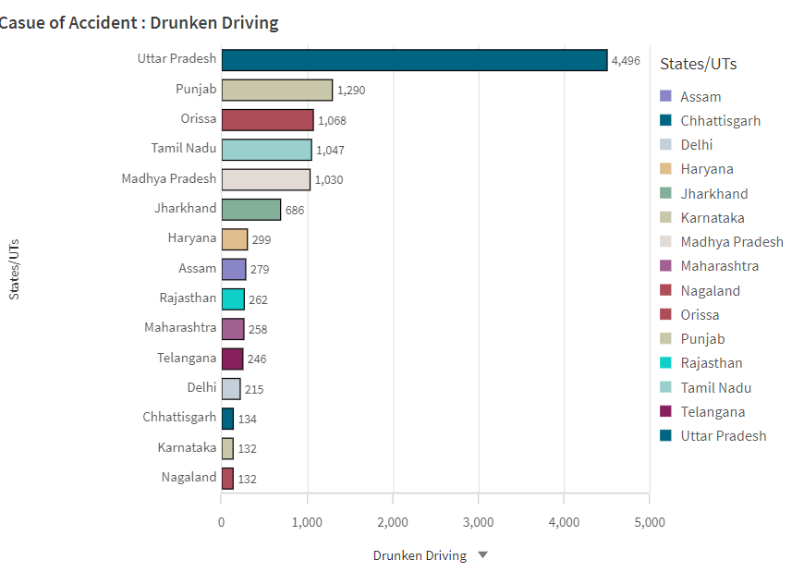

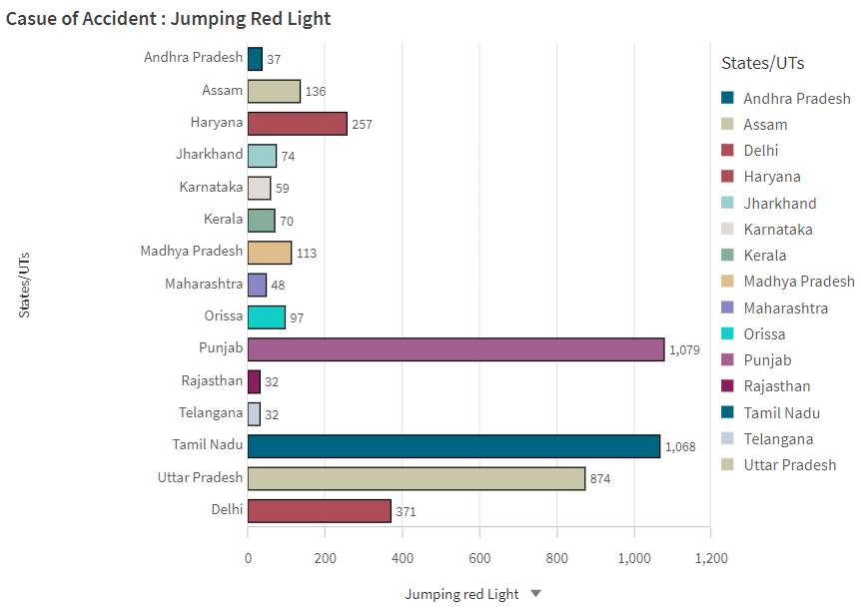

**1.2: State-wise Mobile Phone Usage**

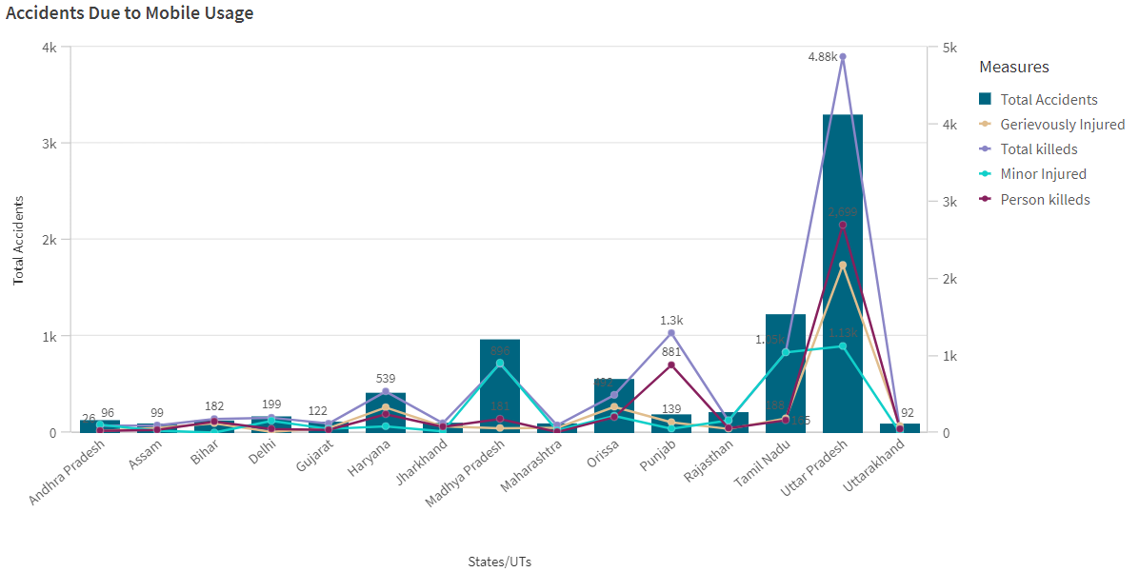

**1.3: Pedestrians Killed: Age groups**

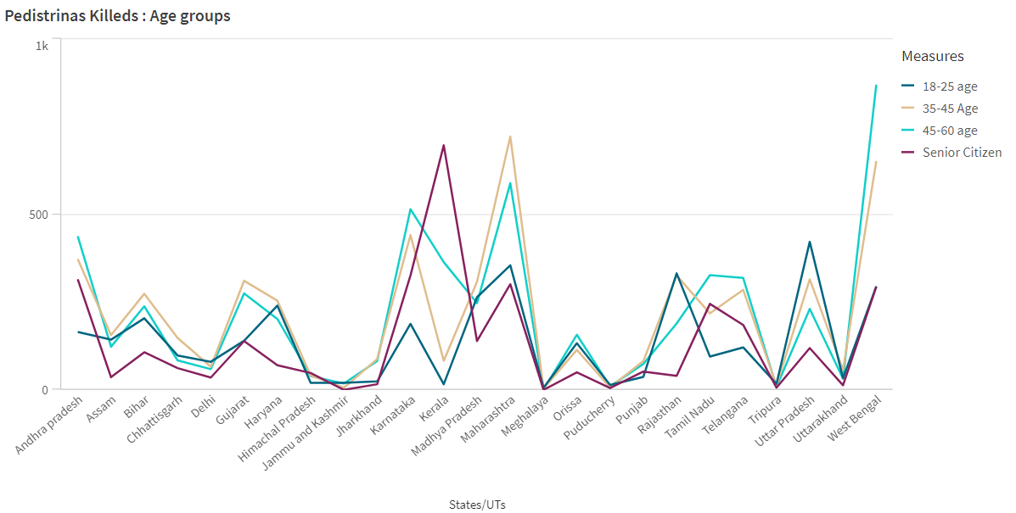

**1.4: Vehicle Contribution towards Total Accidents**

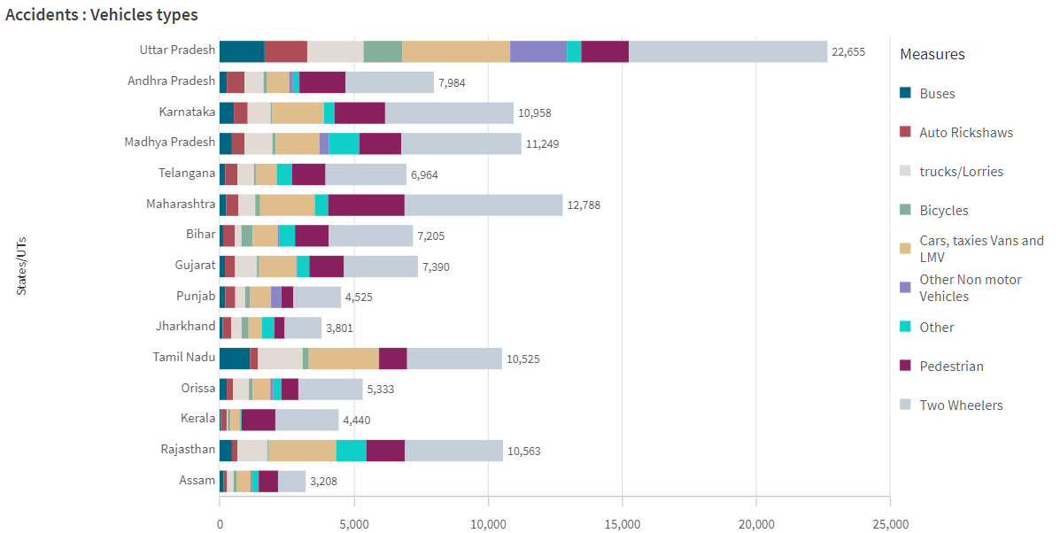

**1.5: Accidents by Weather Type**

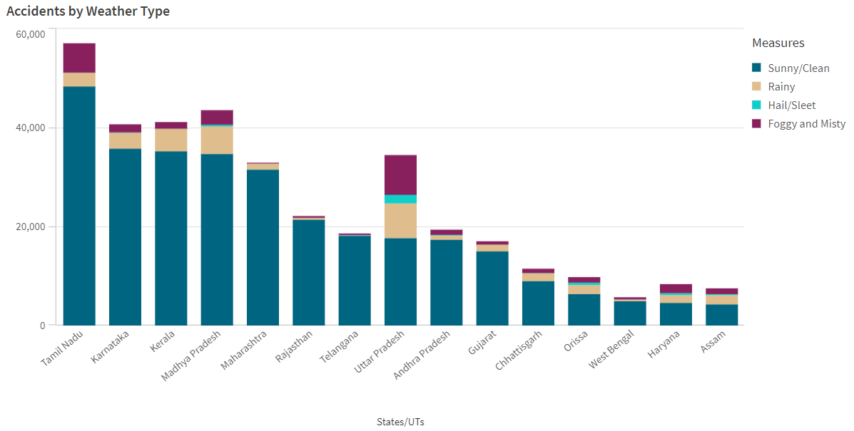

**1.6: Pedestrians Killed: Gender**

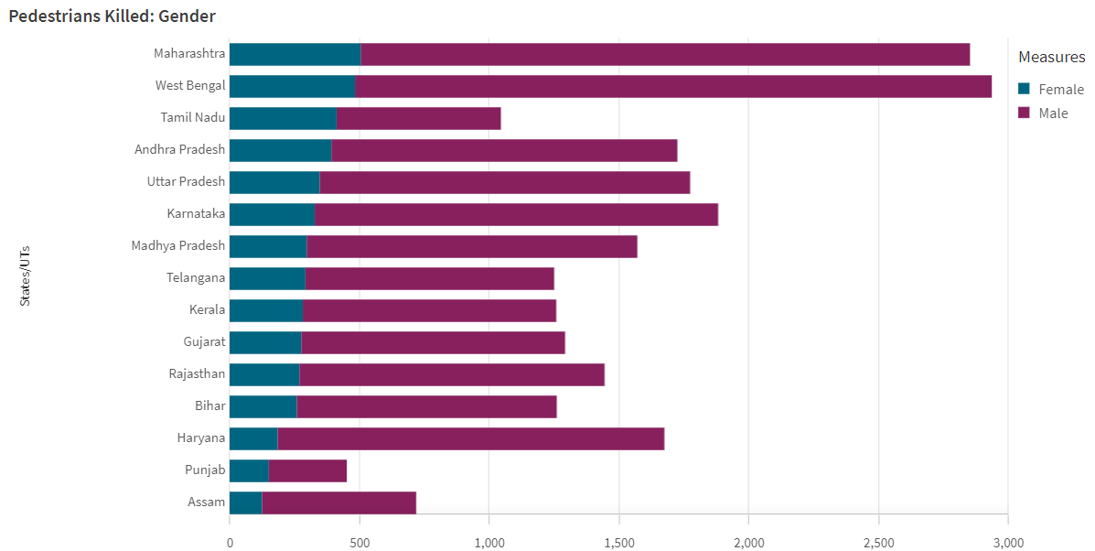

**1.7: Road Users Killed: Vehicle Distribution**

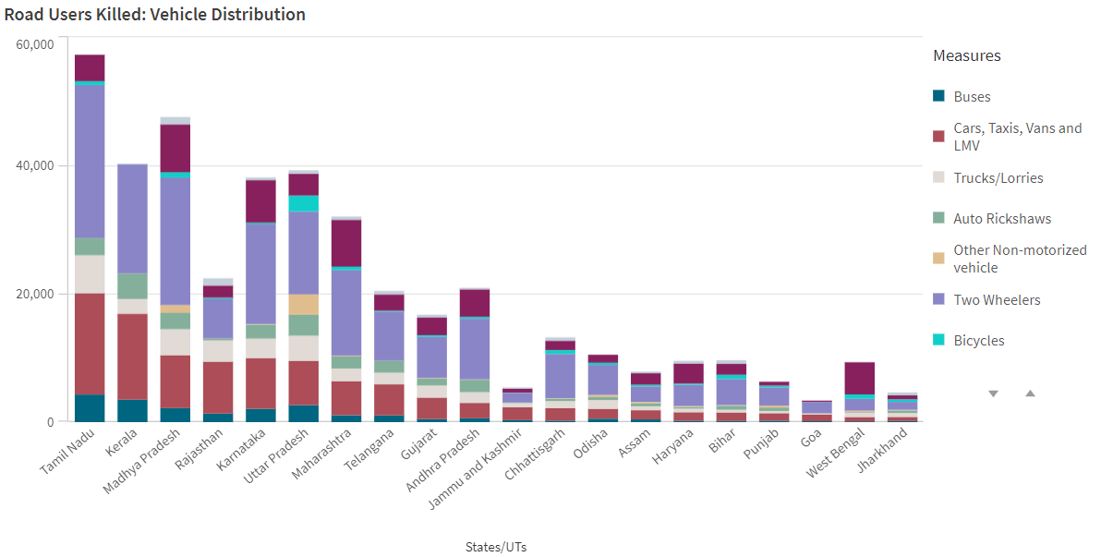

**1.8: Correlation - Speeding and Number of accidents**

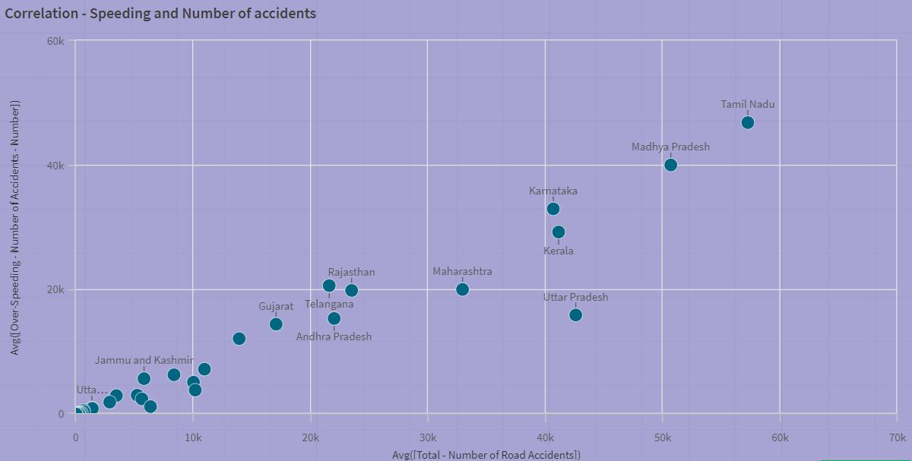

**1.9: Minors Injured across the country**

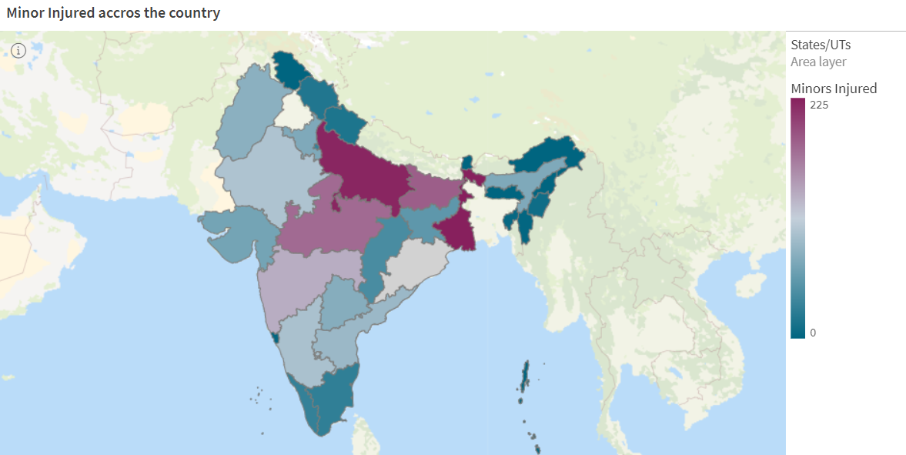

**6. Dashboard**

A graphical user interface (GUI) called a dashboard presents facts and information in a logical and readable manner. Dashboards are frequently used to give data monitoring and analysis in real time. Usually, they are created with a particular use case in mind. Dashboards have application in diverse domains, including business, finance, manufacturing, healthcare, and numerous other sectors. They can be used to monitor performance metrics, track key performance indicators (KPIs), and present data as tables, graphs, and charts.

**Dashboard: Accidents near Traffic Signals**

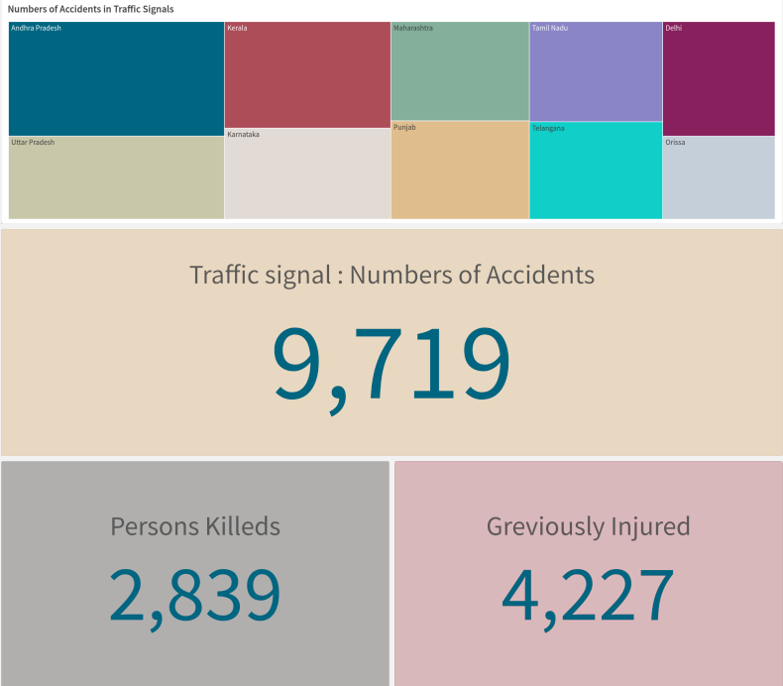

**Dashboard: Accidents in Police Controlled Areas**

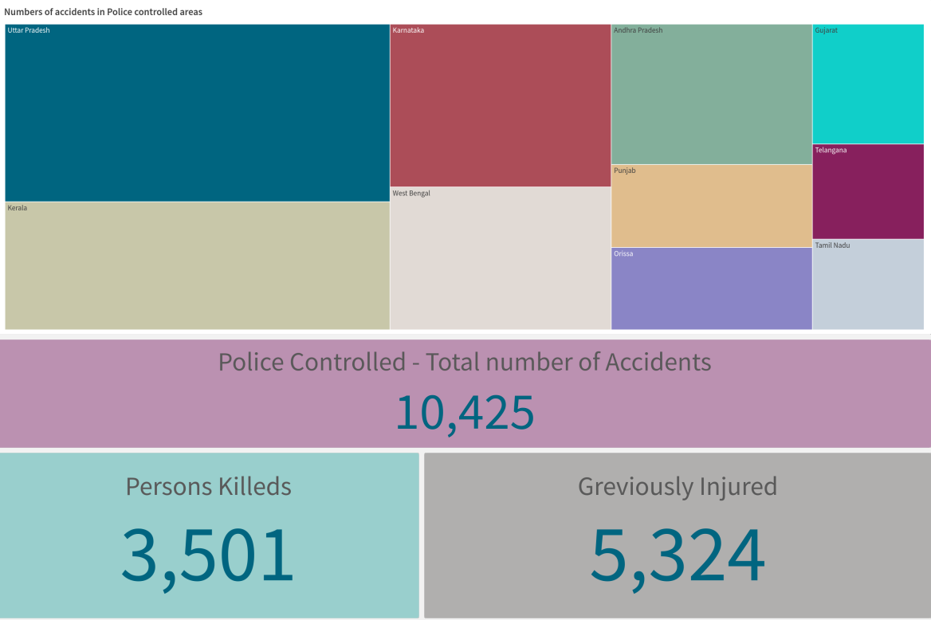

**7. Conclusion:**

Road accidents are a devastating consequence of our modern world, taking countless lives and leaving many more with life-altering injuries. While our love for the freedom of the open road is understandable, it must be balanced with a deep respect for safety. To achieve this, a multi-pronged approach is needed. Firstly, driver education must be emphasized, ensuring everyone understands the rules of the road and the dangers of reckless behavior. Secondly, infrastructure improvements are crucial. Safer roads, better signage, and a focus on eliminating dangerous intersections will create a more forgiving environment for mistakes. Finally, law enforcement must play a strong role in deterring dangerous driving through stricter enforcement of speed limits, DUI laws, and distracted driving regulations.